1.Unwanted pop up display while navigate the dashboard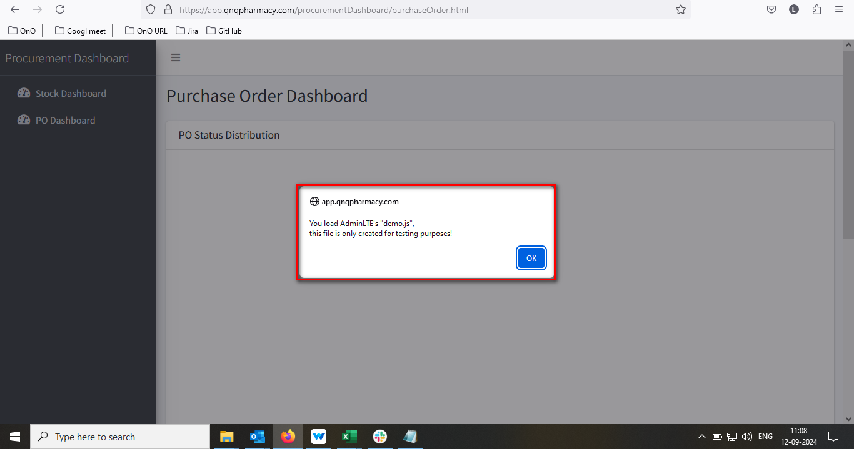

//

2.Minus value display in graph when there is no data available

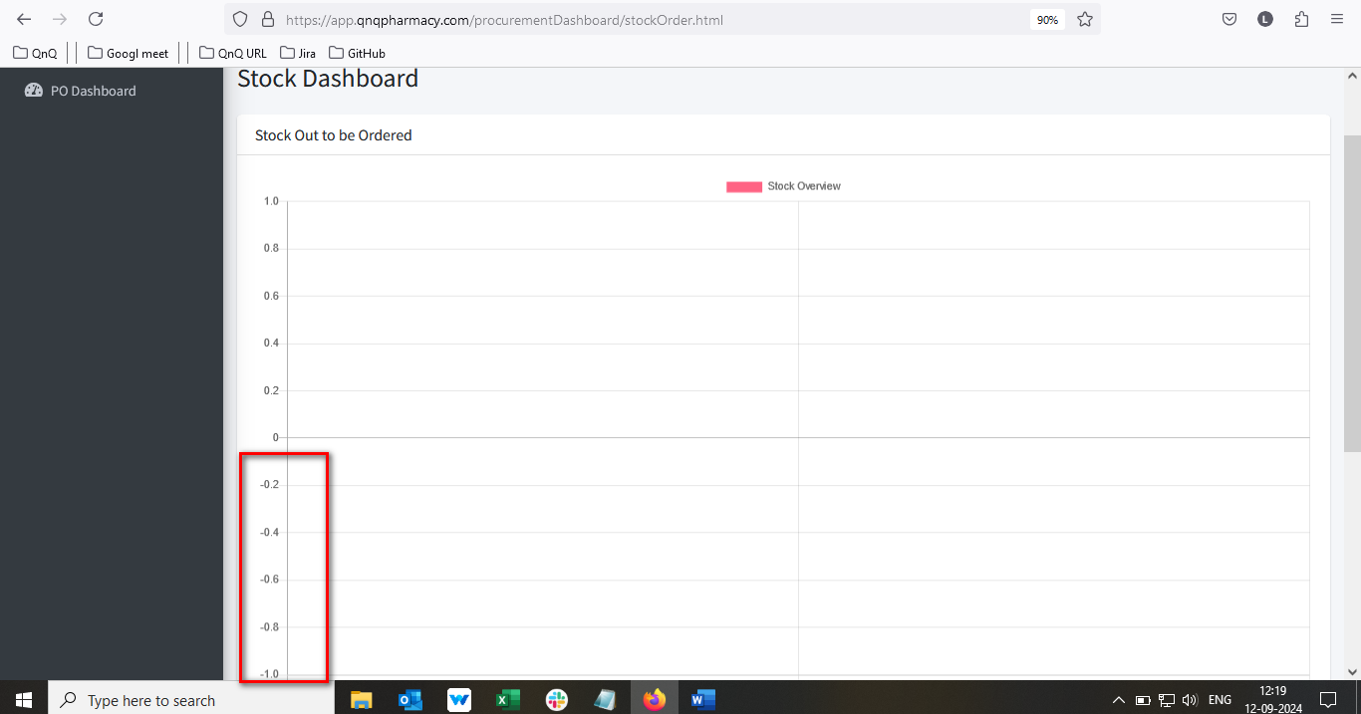

//

3. Mismatch header value display in graph section 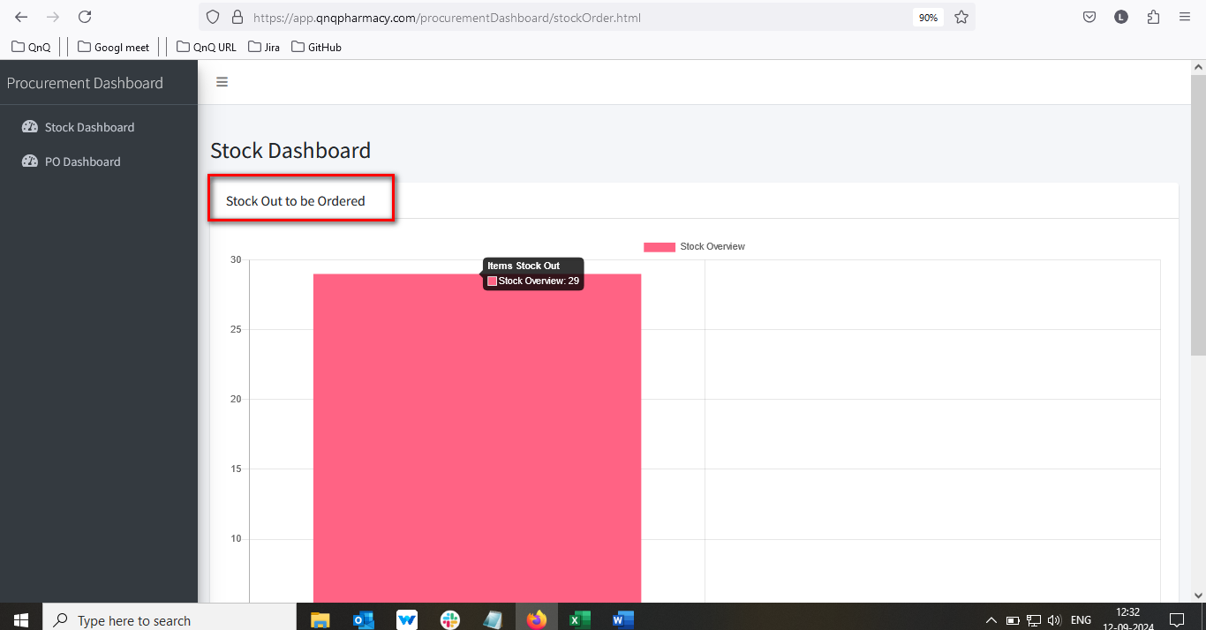

//

4. Decimal value display in graph y axis section 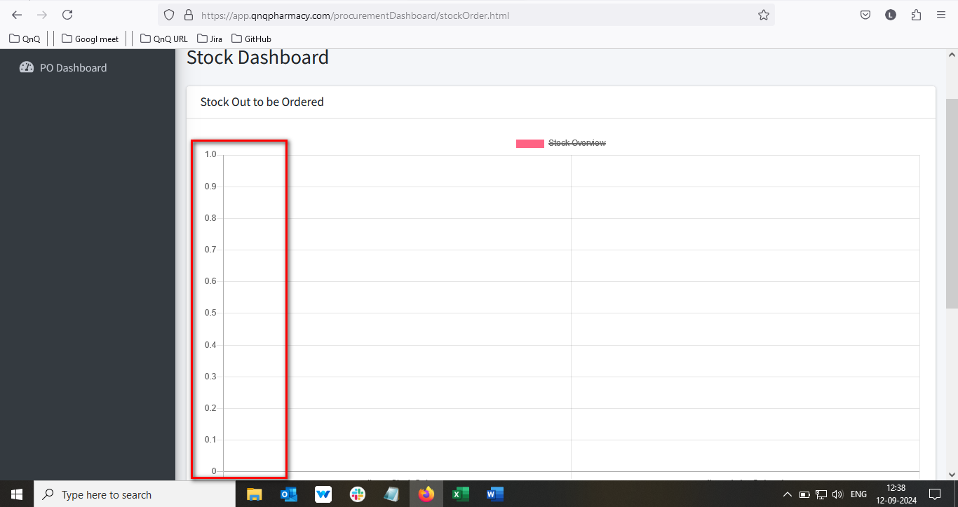 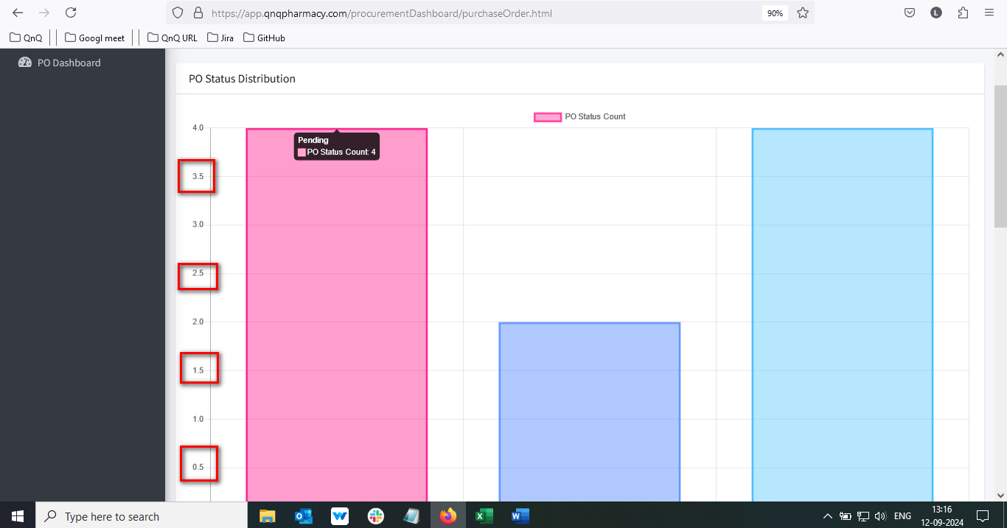

//

5. Unwanted colour highlighted bar display in top of the graph section

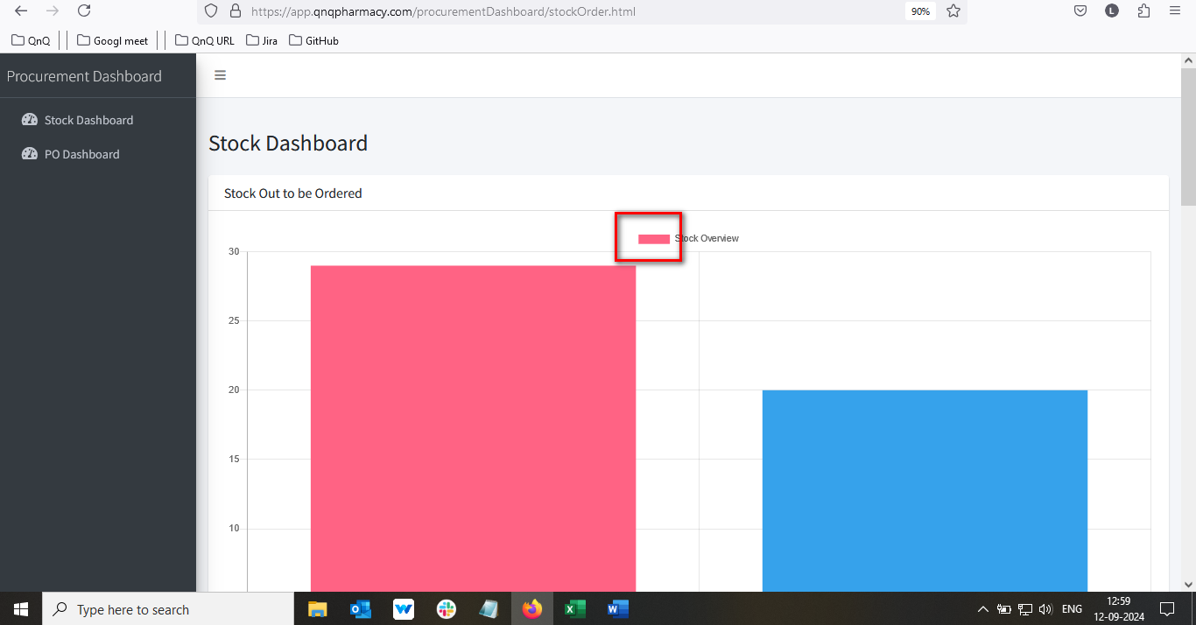 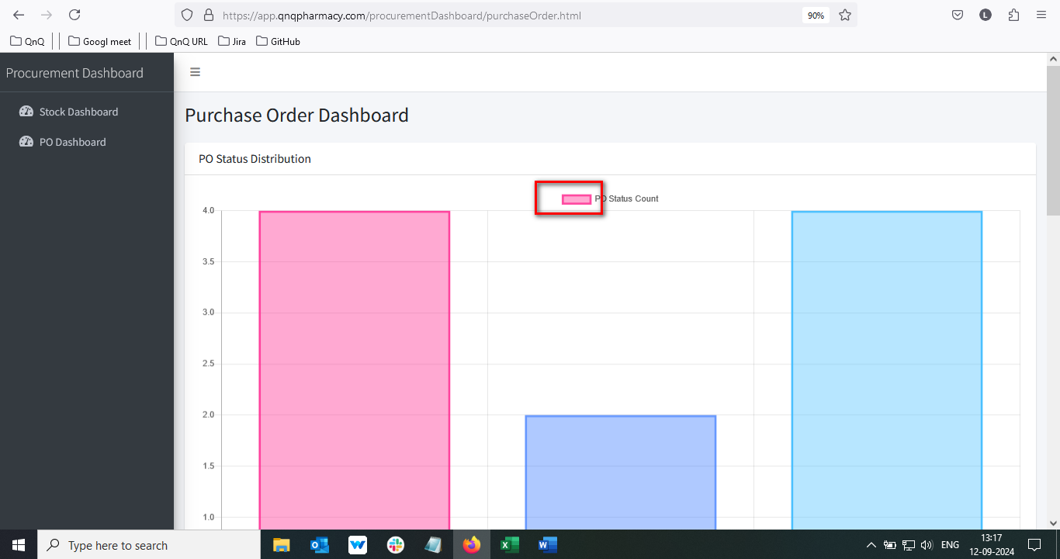

//

6. Unwanted content display in graph tooltip 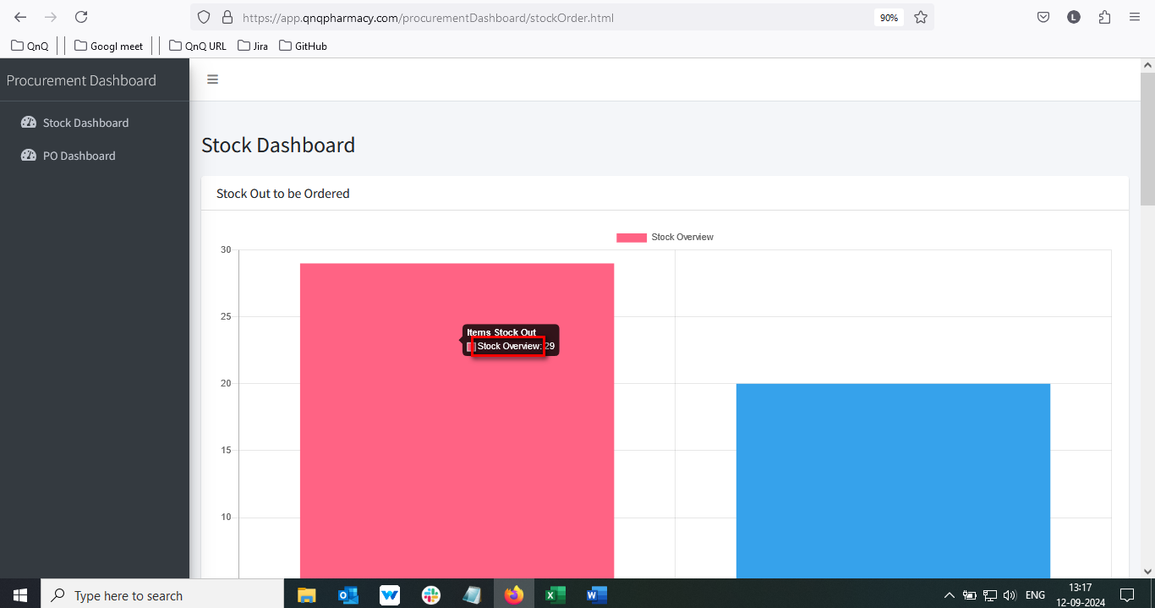

//

7. Mismatch status label name display in list grid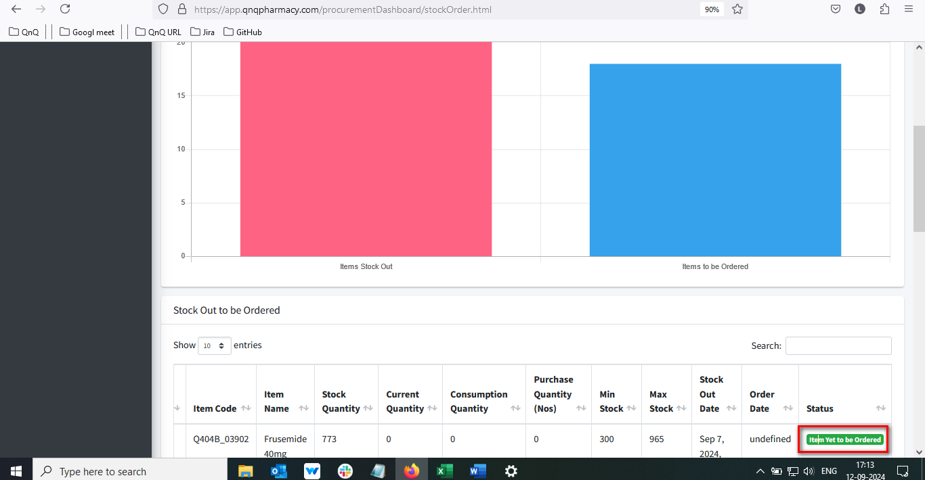

//

8. Order date column display the value as “undefined”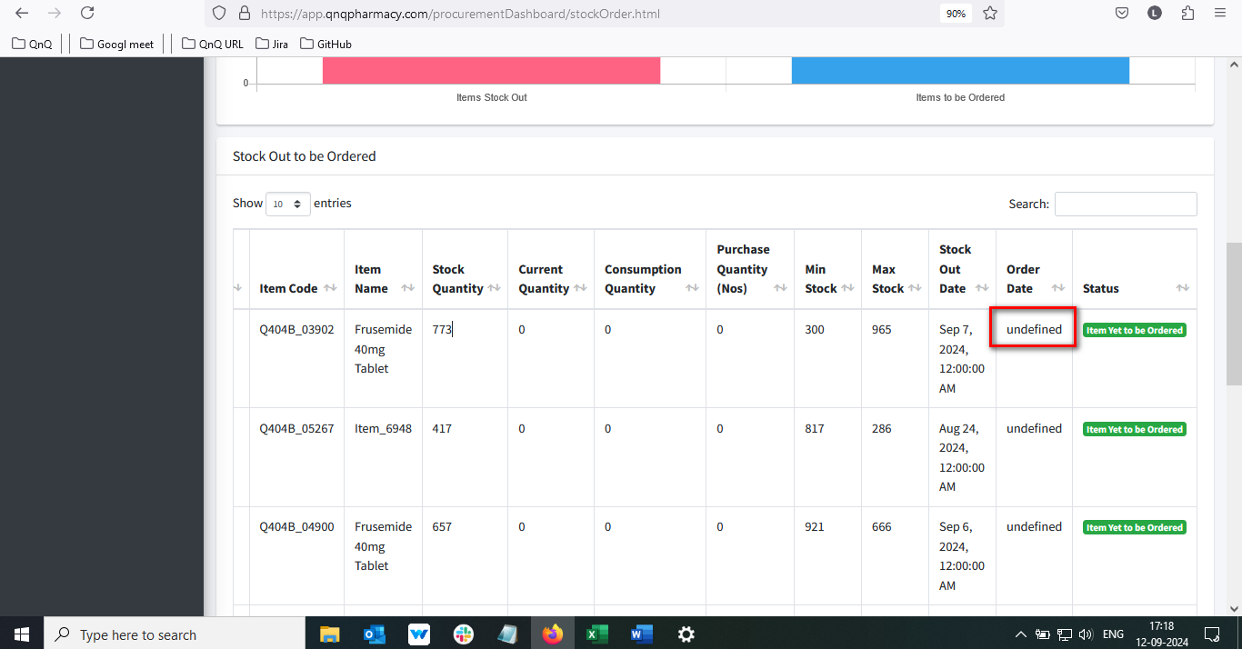

//

9. Column name display improper alignment in list grid 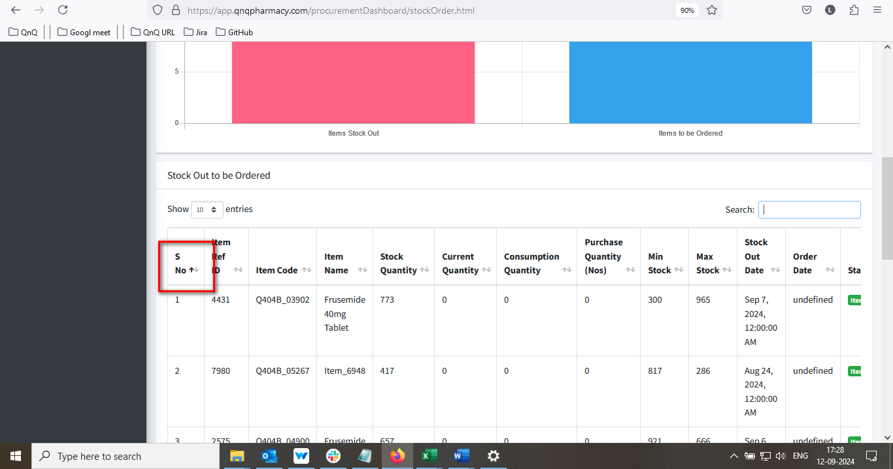

//

10. Placeholder or inner text not display in Search filter text box 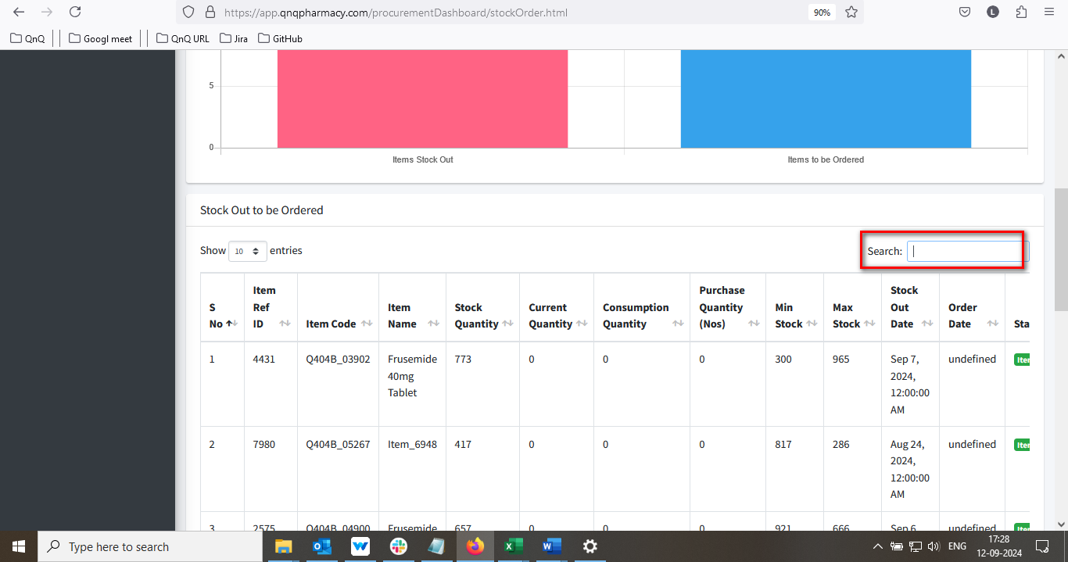

//

11.Time value display in Stock out date column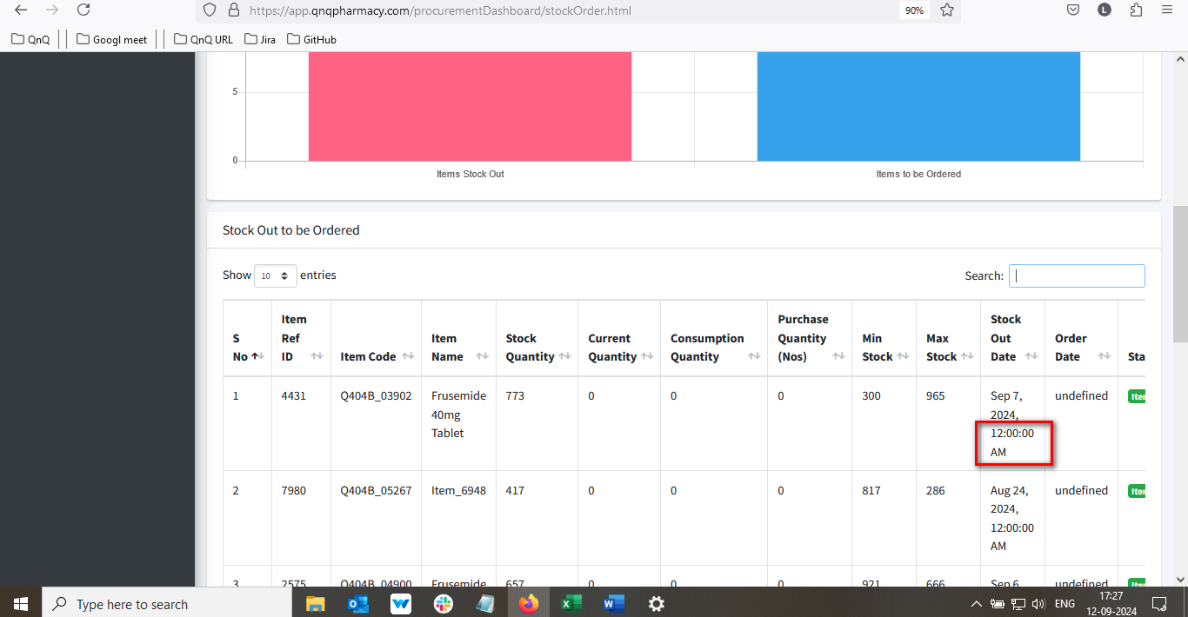

//

12. Dot value not getting display for S.No. in Stock Dashboard 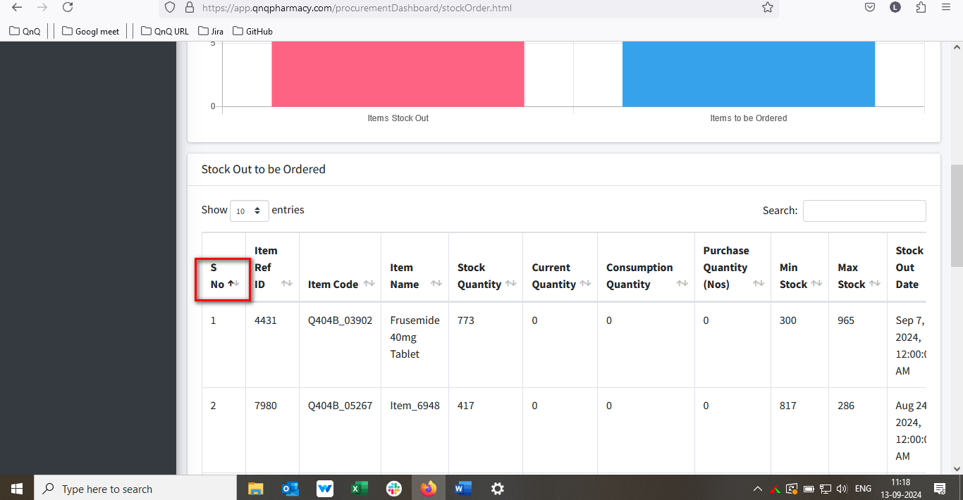

//

13. Mismatch menu icon display for Stock Dashboard 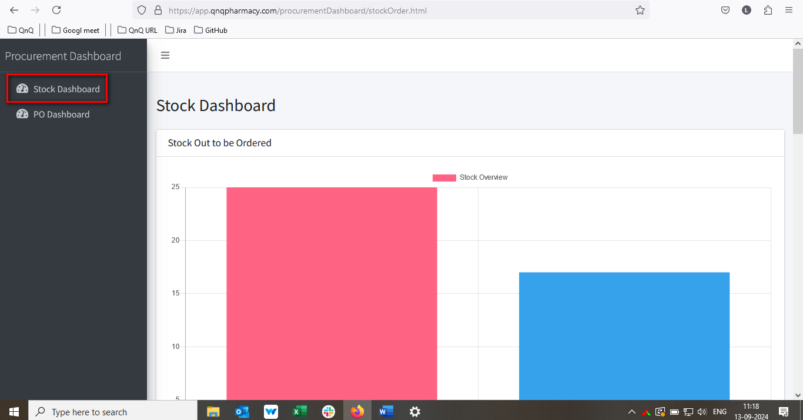

//

14. List grid alignment getting collapse while zoom out the web page view 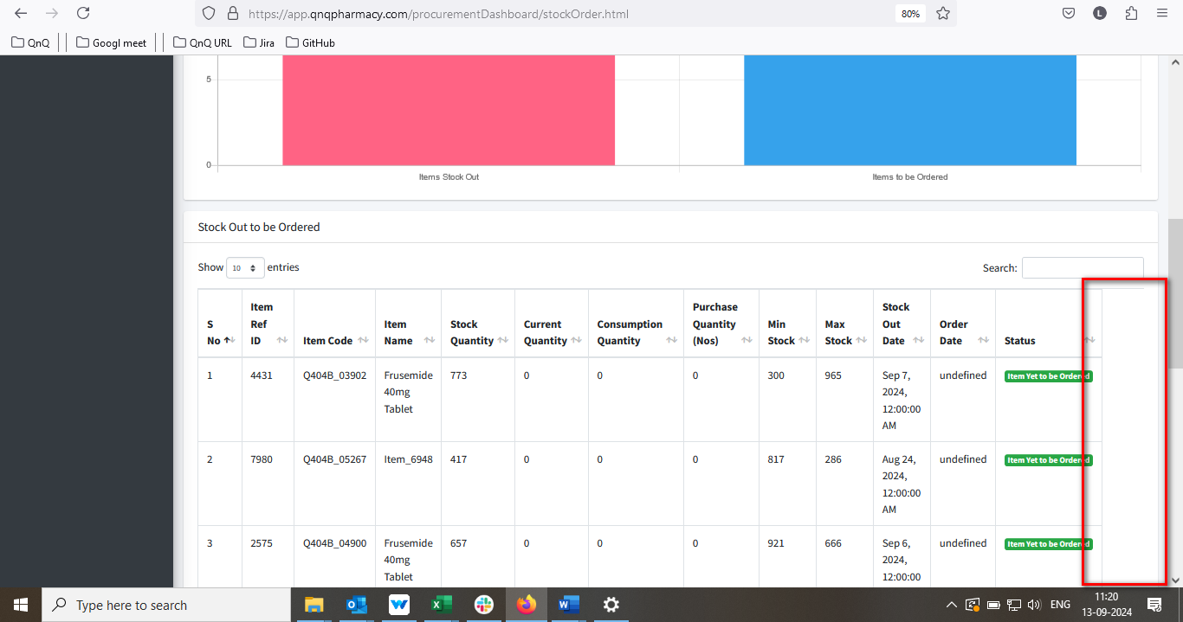

//

15. Sort icon display as too small 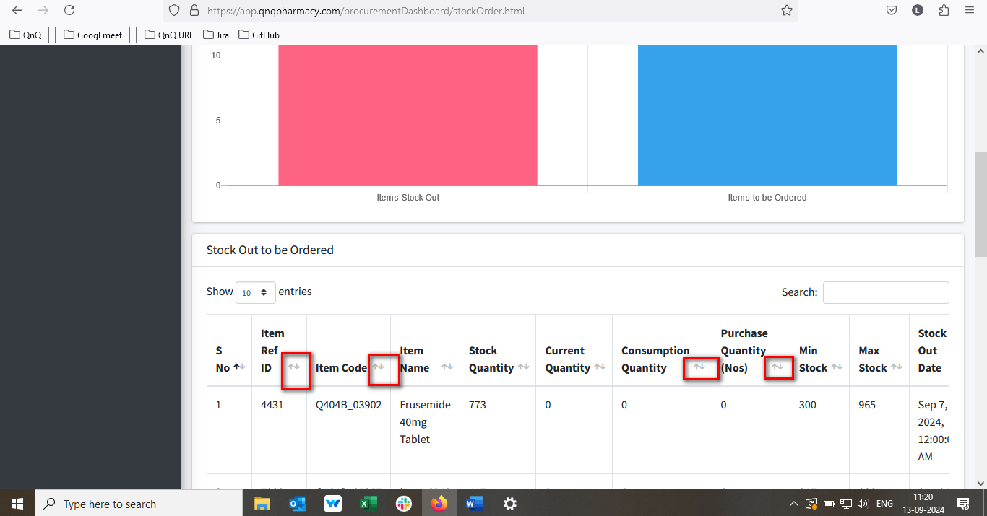

//

16. Mismatch date format display in list grid 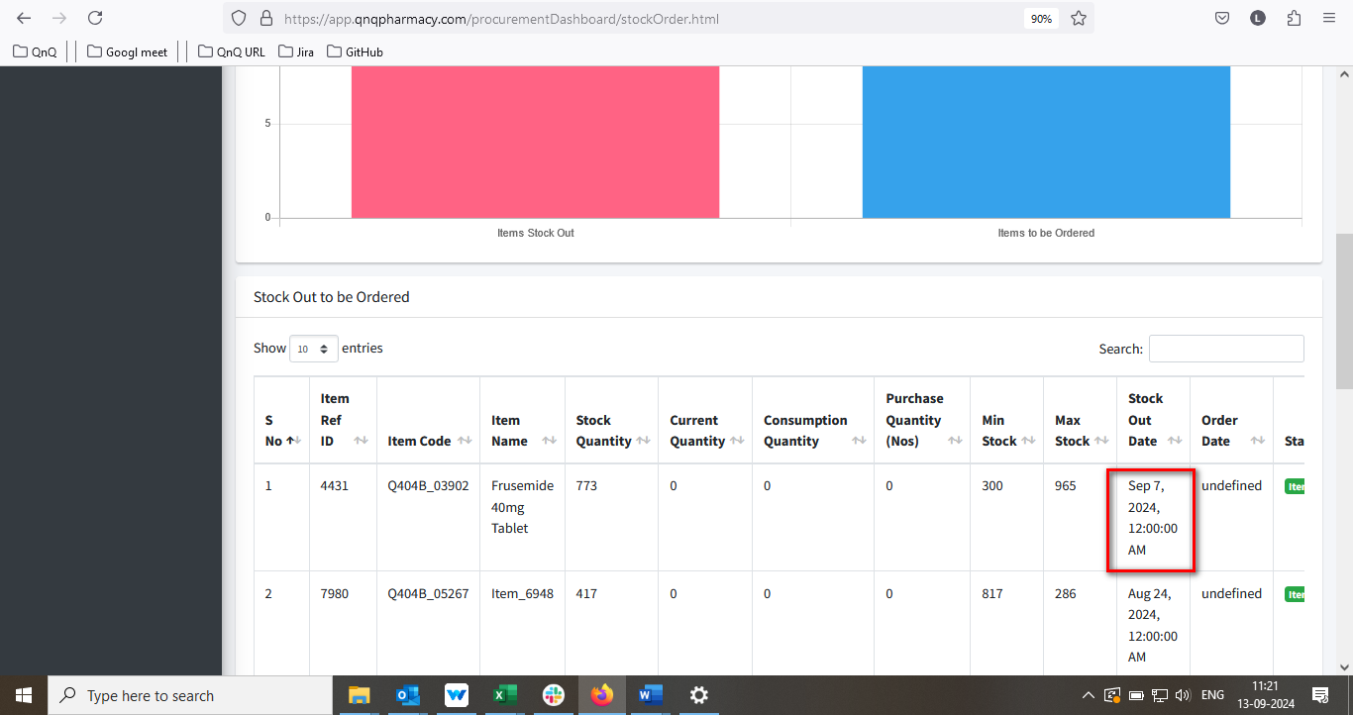

//

17. Mismatch header value display in Po Dashboard list grid 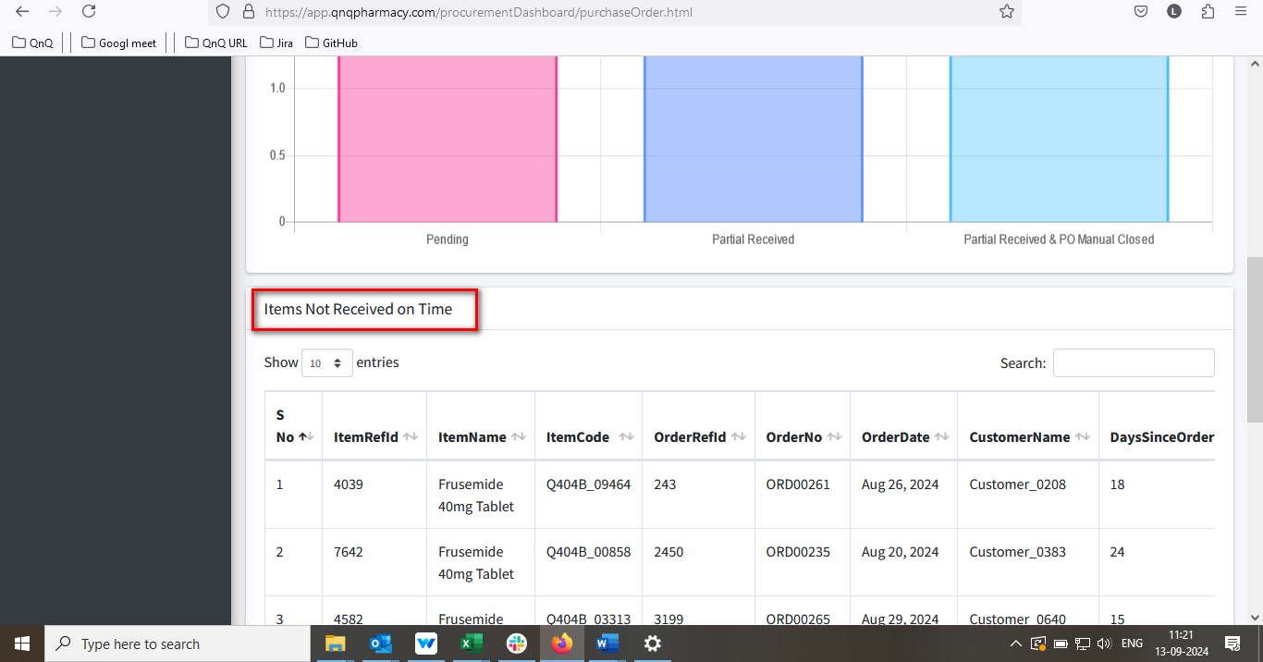

//

18. Unwanted colour highlighted bar display in top of the graph section 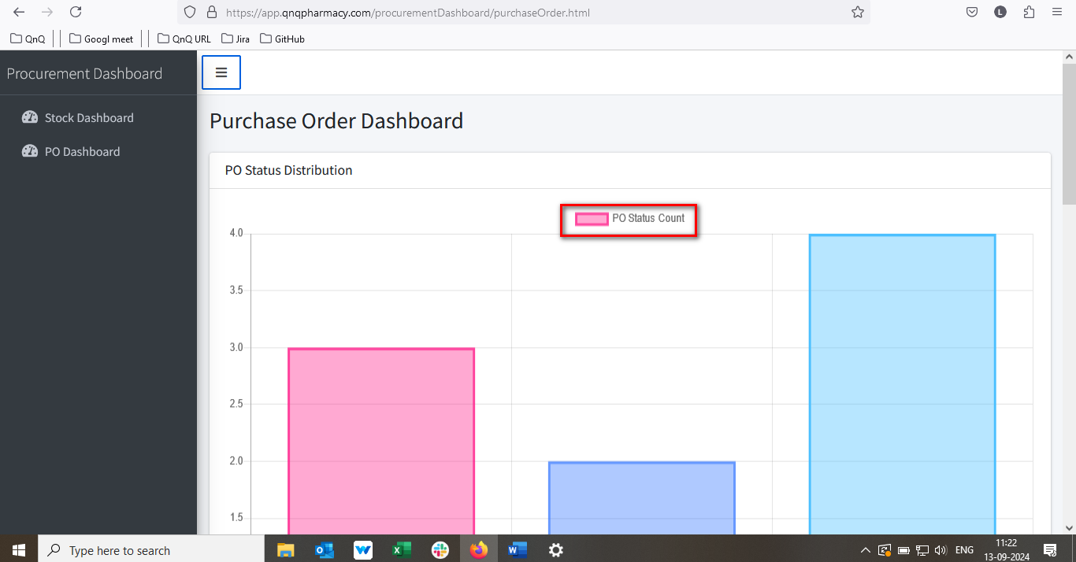

//

19. Unwanted content display in Po Dashboard graph tooltip 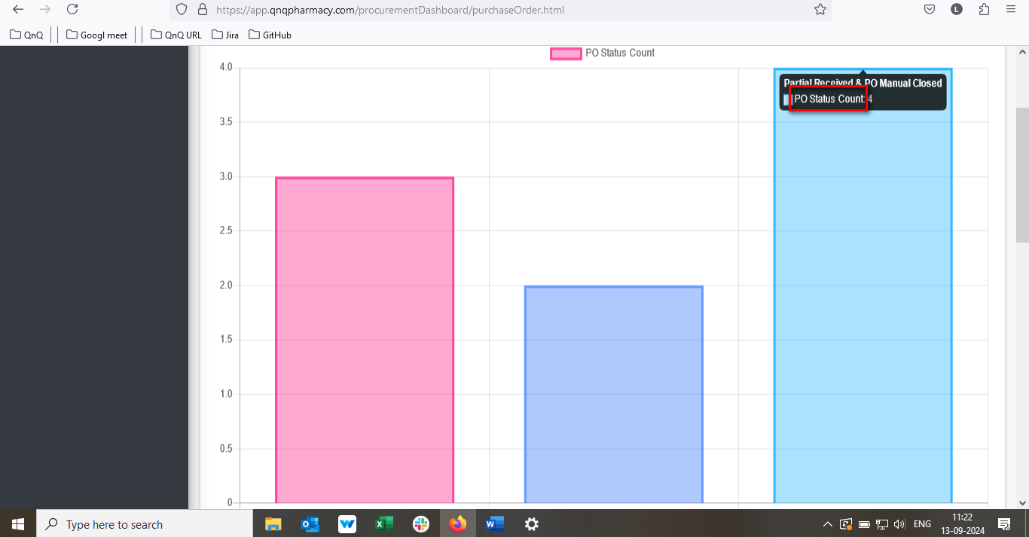

//

20. Column name display improper alignment in Po Dashboard list grid 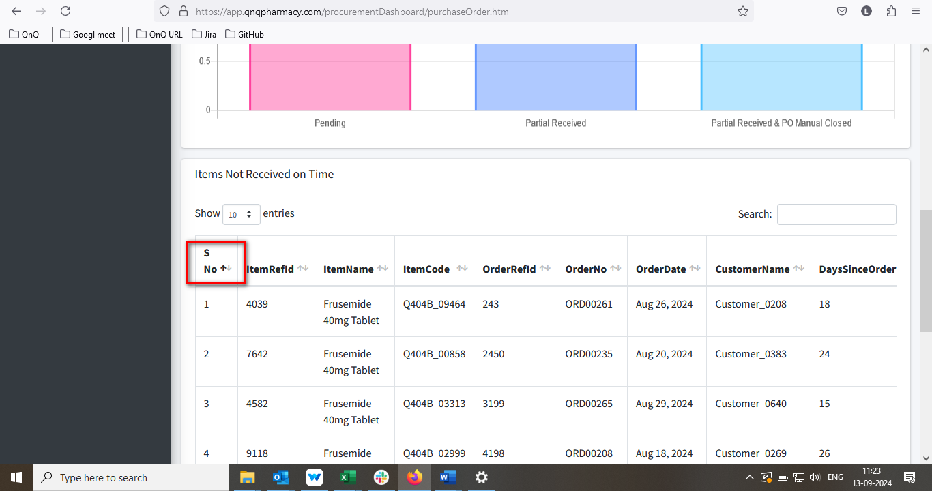

//

21. Dot value not getting display for S.No. 

//

22. Mismatch menu icon display for Procurement Dashboard 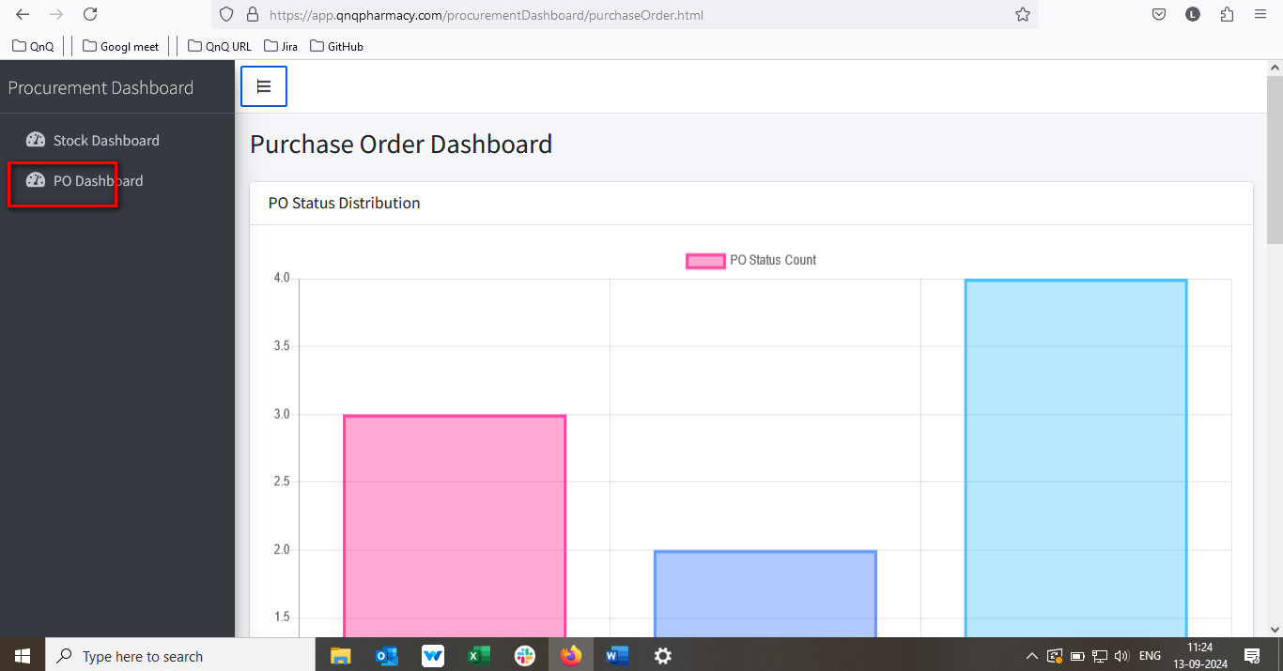

//

23. List grid alignment getting collapse while zoom out the web page view 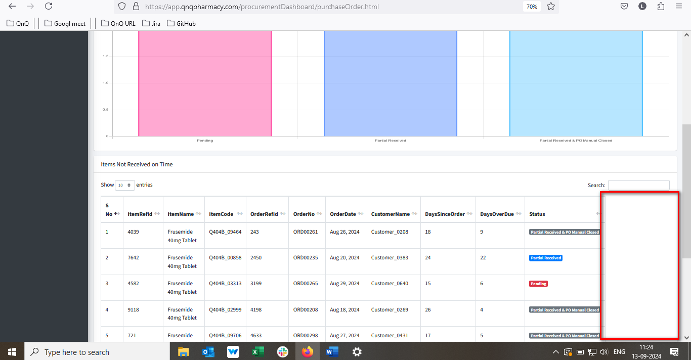

//

24. Mismatch date format display in list grid 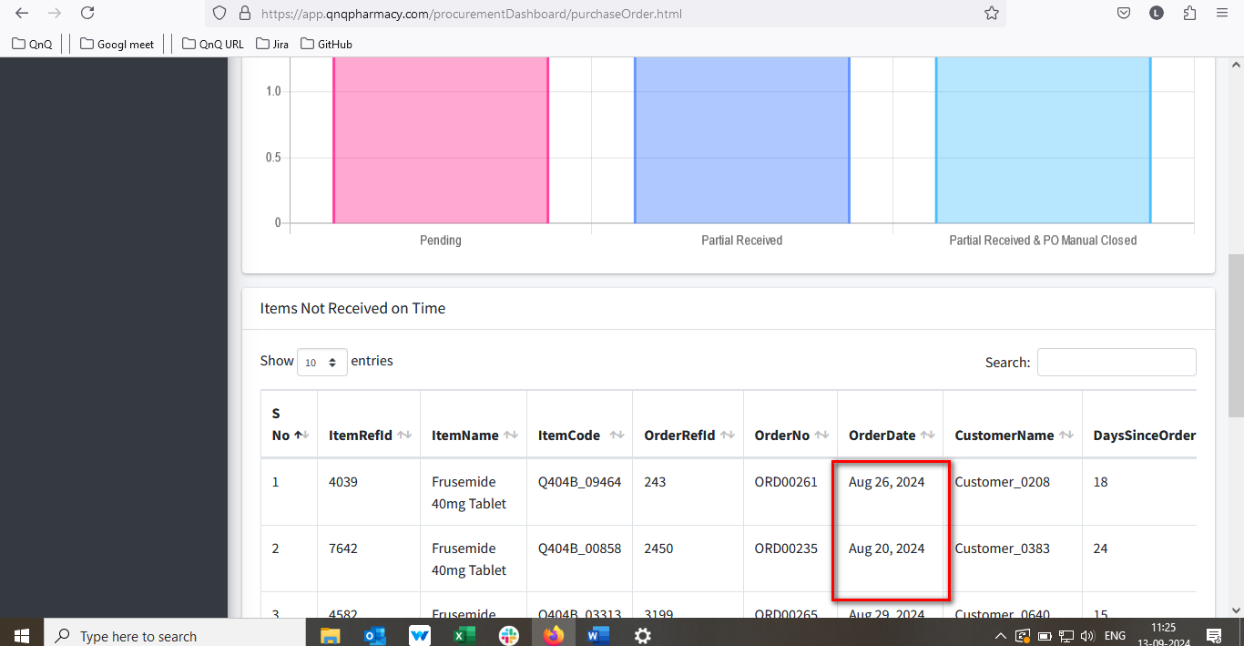

//

25. All Column header name display without space 

